**Better Reviews**

By

**Asrith Neti**

B.Tech., Marri Laxman Reddy Institute of Technology, 2017

GRADUATE CAPSTONE SEMINAR PROJECT 2020

Submitted in partial fulfillment of the requirements

For the Degree of Master of Science,

With a Major in Computer Science



Governors State University

University Park, IL 60484

2020**ABSTRACT**

The project is to build the Better Reviews web application, and it is important because a web application helps businesses to target and reach potential and existing customers easily and quickly. The web application will be a yelp-like application where registered users can rate and review new or existing businesses. Here we have Admin role which has the fore-most access to the website, who has the privilege to manage the infrastructure as well as monitor the performance. Another role is that a User can have the ability to register as a business owner for an existing or new business. The Business owner role is distinct from the reviewer role such that the business owner will appear as an agent of the business and be able to respond to review feedback.

**Table of Content**

***1. Project Description*** 1

1.1 Competitive Information 1

1.2 Relationship to Other Applications/Projects 1

1.3 Assumptions and Dependencies 1

1.4 Future Enhancements 1

1.5 Definitions and Acronyms 1

***2****.* ***Project Technical Description*** 2

2.1 Application Architecture 2

2.2 Application Information flows 3

2.2.1 Front Page 3

2.2.2 Login/Register Page 3

2.2.3 Reviewer Console Page 3

2.2.4 Reviewer Profile Page 3

2.2.5 Business Owner Console Page 3

2.2.6 Business Profile Page 4

2.2.7 Administrative Console Page 4

2.2.8 Search Results Page 4

2.3 Interactions with other Applications 4

2.4 Capabilities 4

2.5 Risk Assessment and Management 4

***3***. ***Project Requirements*** 4

3.1 Identification of Requirements 4

3.1.1 BR-1 User-Registration/Login-0001 4

3.1.2 BR-1 User-Write a review-0002 5

3.1.3 BR-1 User-Create/Search Business-0003 5

3.1.4 BR-1 Business Owner-Post Events/Promote Business-0004 5

3.1.5 BR-1 Business Owner-Upload Profile Image -0005 5

3.1.6 BR-1 Business Owner-Delete Business -0006 5

3.2 Operations, Administration, Maintenance and Provisioning (OAM&P) 5

3.3 Security and Fraud Prevention 5

3.4 Release and Transition Plan 5

***4***. ***Project Design Description*** 6

4.1 Sequence Diagram: 6

4.2 E-R Diagram 6

4.3 Database Schema Diagram 7

***5***. ***Internal/external Interface Impacts and Specification*** 7

5.1. External: Front-end 7

5.2. Internal: Back-end 8

***6***. ***Design Units Impacts*** 8

6.1. Functional Area A/Design Unit A 8

***6.1.1*** ***Functional Overview*** 8

***6.1.2*** ***Impacts*** 8

***6.1.3*** ***Requirements*** 8

6.1.3.1 Functional Requirements 8

6.1.3.2 Non-Functional Requirements 9

***7***. ***References*** 9

***8***. ***Appendices***: 10

# Project Description

The Better Reviews (BR) application connects people with great local businesses. It expands the reach of business owners to consumers i.e., customers, by virtue of being found via a simple search query on the application. Better Reviews amplifies engagement by promoting interactivity with businesses and customers. Features such as bookmarking a business or checking-in go beyond the free page listing that any business can claim. With unmatched local business information, photos and review content. Better Reviews provides a one-stop local platform for consumers to discover, connect and transact with local businesses of all sizes by making it easy to know about upcoming events and their available services. In the future BR will also be able to request a quote and make appointments.

## Competitive Information

Competitor applications are such as Open Table and Zagat. Unlike these two platforms where the search results for the restaurants have been very wrong and are nowhere close to the selected option, BR excels by being able to match on a few, but key data attributes to always get you to the business you are looking for. Also, BR’s photo library is dynamic and responsive unlike the competitor where the images are not compatible with all devices. Also, Zagat and Open table have the smaller user base which has the same functionality used in the reviews system, which make customers toggle between the users. Since BR is comparable in size and offers similar features, supporting a user base like Open Tables and Zagat will be easy for BR. In fact, BR will excel due to the fact that it is using a lightweight and robust database system, MariaDB 10.3.6.

## Relationship to Other Applications/Projects

Our project is very similar to few products in the market such as:

* Yelp
* Zomato
* Open table
* Zagat

Even though they are similar, our application is unique in terms of features and reliability.

## Assumptions and Dependencies

* Better Reviews is a user-friendly web application.
* In this web application, the users cannot directly reserve a table online. However, users can contact the restaurant for the reservations.
* This web application doesn’t have the efficiency of verifying the users(fake/genuine).
* Google Single-Sign on
* Laravel PHP Framework

## Future Enhancements

This project has great ambitions in terms of new features in the future. The enhancements can be implemented into the web application in near future as when requirements are gathered, and impacts are assessed for each new feature. Either way, because BR was developed using the object-oriented approach, the platform is very flexible in terms of expansion.

## Definitions and Acronyms

BR: Better Reviews- It’s a web application which can be accessed by anonymous and registered users to search, review the restaurants accordingly to their interest

PHP: Personal Home Page server-side language

RDBMS: Relational Database Management System

MariaDB/MySQL: Open-source database management system.

HTML5: Hypertext markup language, version 5. Modern version of the most important markup language used by all types of browsers.  
CSS3: Cascading style sheets, version 3. Provides styling of aesthetics in modern applications in browsers.

Bootstrap: Open-source grid-style layout system originally developed by the developers at Twitter.

Docker: Cross platform containerization program allowing developers to develop against Linux images.

JavaScript: Client-side language used to make standard HTML dynamic and interactive.

jQuery: A JavaScript library commonly used to replace long and verbose methods of standard JavaScript.

# Project Technical Description

Our team built the Better Reviews web application for our stakeholder, Dr. Xin Chen. The web application is a yelp-like application where registered users can rate and review new or existing businesses. Here we have Admin role which has the fore-most access to the website, who has the privilege to manage the infrastructure as well as monitor the performance. Another role is that a user can have the ability to register as a business owner for an existing or new business. The business owner role is distinct from the reviewer role such that the business owner will appear as an agent of the business and be able to respond to review feedback.

We built our application using the Laravel PHP framework in Laravel 5.8 and PHP 7.3.22. Laravel allows for rapid, but standardized, development as it abstracts the connection to the database, session management, and file handling (I/O). Because of the abstraction, developers can focus on building the application at hand and worry less about the nuances of these topics in PHP.

For RDBMS we used MariaDB 10.3.6, which is a MySQL drop-in replacement. For web servers we utilized Nginx 1.10. Lastly, for front-end programming we used HTML5, CSS3, Bootstrap library, JavaScript, and jQuery.

To further assist development, we used Docker to containerize our development. Docker will afford the ability for each developer to develop against the same engine which rids of the age-old problem of, “well it runs on my computer…”. Also, because the creation of the containers will be uniform, regardless of host OS, we no longer have to worry about the nuances between the server-side programming language and the server OS. Docker also helps ensure all developers are using the correct versions of each of the vital components of the application stack: server-side language, web server, and database.

We deployed our application onto an Ubuntu Linux server. Our application will run in Docker containers. Traffic from the internet will go through the Ubuntu machine and reverse-proxied to the Docker container within.

## Application Architecture

**Web Client:** A web browser that has access to connect with the web application.

**HTTPS Protocol:** The security of HTTPS is that of the underlying TLS, which typically uses long-term [public](https://en.wikipedia.org/wiki/Public-key_cryptography) and private keys to generate a short-term [session key](https://en.wikipedia.org/wiki/Session_key), which is then used to encrypt the data flow between the client and the server.

**Web Server:** A web server is [server software](https://en.wikipedia.org/wiki/Server_software) or [hardware](https://en.wikipedia.org/wiki/Computer_hardware) dedicated to running this application, that can satisfy client requests on the [World Wide Web](https://en.wikipedia.org/wiki/World_Wide_Web). It processes incoming [network](https://en.wikipedia.org/wiki/Computer_network) requests over [HTTP](https://en.wikipedia.org/wiki/Hypertext_Transfer_Protocol)S [protocols](https://en.wikipedia.org/wiki/Communication_protocol).

**Server-Side Script:** The core of the web application that listens to requests from the web client and are passed from the web server. These scripts are in charge of interpreting said requests and passing it through the various business logic at the heart of Better Reviews. Such scripts include verifying the authentication and authorization of a user by checking the user's access rights.

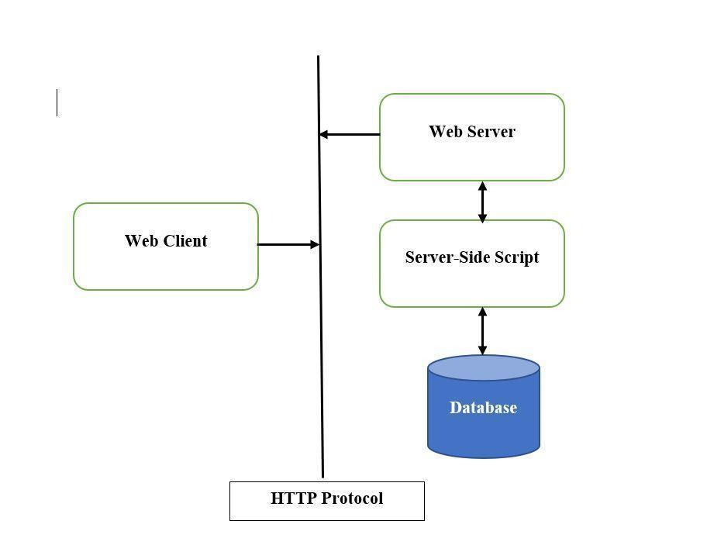

***Figure 1-Application Architecture***

## Application Information flows

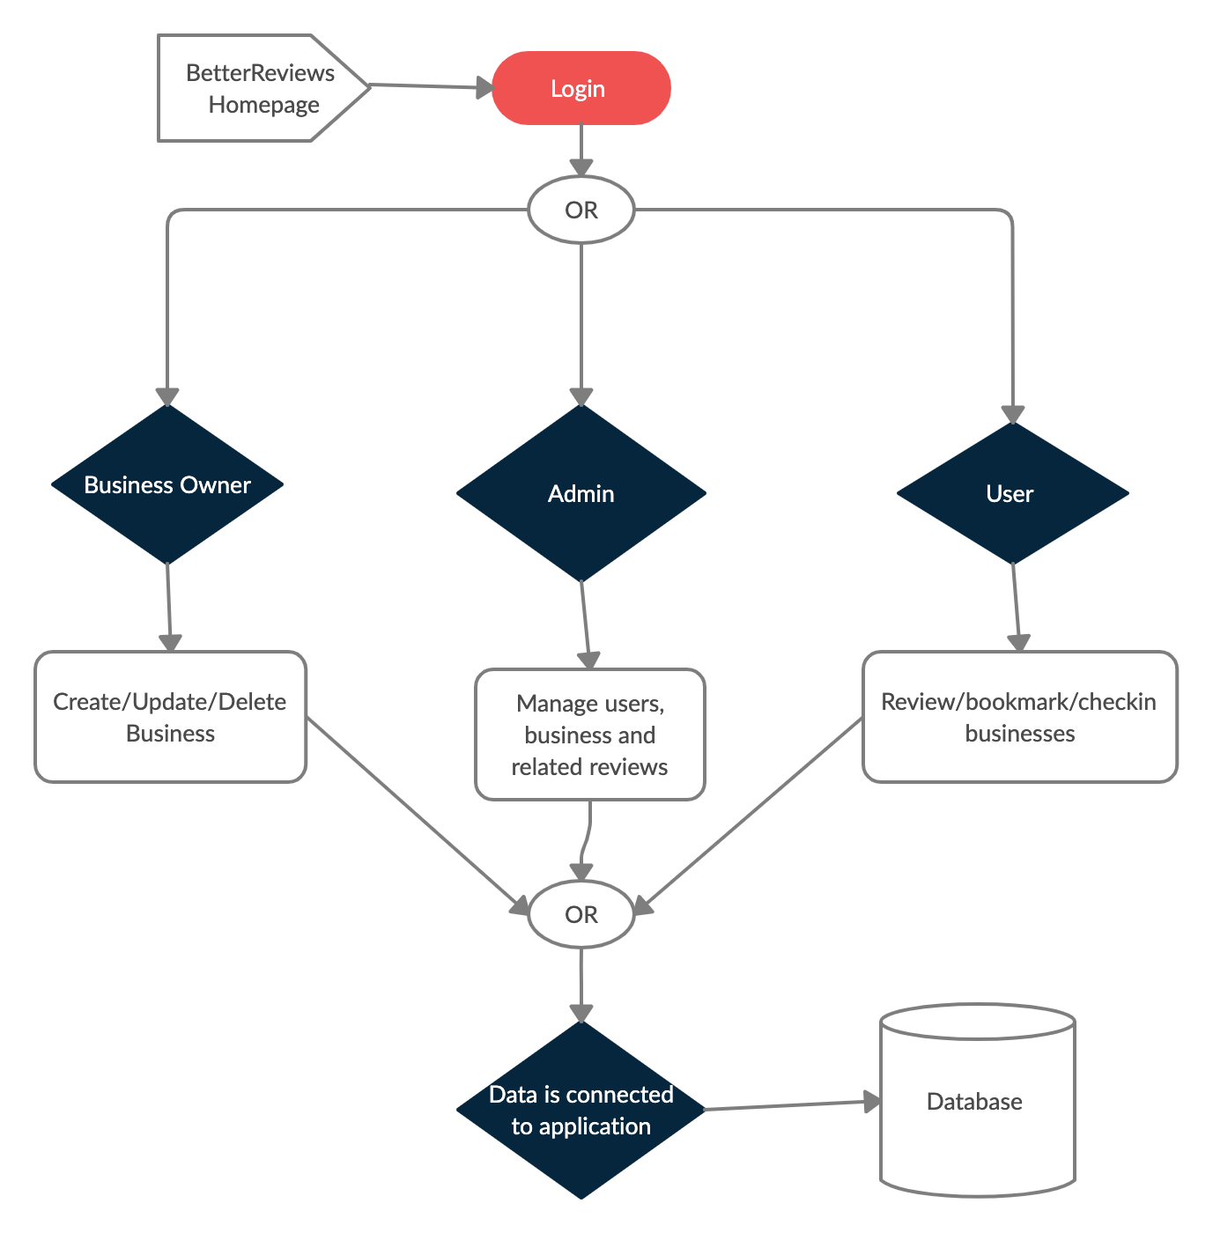

***Figure 2- Application Flow Chart***

### Front Page

The main page is considered the hub for all additional actions. This page will feature a business promotion area where a business can be promoted (by an admin) for a specific amount of time.

### Login/Register Page

Login page provides access to the account or acquires credentials. After login the user can update their account, connect with customers, or register a business.

### Reviewer Console Page

This page is available after login and shows the latest reviews by this reviewer, events from businesses and latest check-ins performed by the reviewer. Through the console the reviewer has the ability to access and update most of their settings.

### Reviewer Profile Page

Public access page for a specific reviewer to view profile details. Provides ability for users to rate reviews from this reviewer. Show public bookmark collection and display count of reviews submitted.

### Business Owner Console Page

Page where a user has access to update and set the business profile. Access to upload images, update available business services, create business events, respond to business questions.

### Business Profile Page

Public access page for a specific Business Profile Page. Allows the user to write a review for the business, to vote on the star rating of business. Users can also bookmark business and check-in.

### Administrative Console Page

This page allows an operator to manage certain server controls from the front-end. Administrative console is used to configure security parameters, including managing user profiles, user feedback and business profiles.

### Search Results Page

This page’s basic role is to show the items matching a given query. The page also allows you to sort the results by a given set of advanced search options. We will also attempt to create an autosuggest feature on keypress to better assist the user.

## Interactions with other Applications

The following are the applications required in order to interact with other applications:

* Laravel PHP framework in Laravel 5.8 and PHP 7.3.22
* For RDBMS we used MariaDB 10.3.6
* Docker to containerize our development
* Data grip 2020.2.3 IDE used to interact with database via GUI
* PHP storm 2020.2 IDE used to develop the application

## Capabilities

1. **Crucial Business Information**: Business information like contact details, navigation, menu URL, etc. can be updated by the business owner whenever it is necessary.
2. **Social Media Integration:** Social Media is a critical part for marketing the business. This facility is provided to business owners to attach their social media platform links to their business profile.

## Risk Assessment and Management

1. Potential for too much traffic that could take down the database or web server.
   1. Potential Resolution: Scale the webserver and database to meet 1000/requests per second.
2. Potential for too much traffic that could cause storage space issues on the Linux VM.
   1. Potential Resolution: Add additional 500 GB volume to handle this load.
3. Potential for downtime due to inadequate redundancy of application.
   1. Potential Resolution: Add additional nodes on a load balancer that can be switched to on a moment’s notice.
4. Potential for bots and fake users to fill our user table and thus exhaust database connections and storage issues.
   1. Potential Resolution: Add stringent firewall rules and Google Captcha to ascertain if the user is “real”.
5. Potential for disgruntled users to write damaging remarks or questions about a business.
   1. Potential Resolution: Change the question and review approach to be disabled at first and then approved after a command can read the review to ensure foul language or sentiment is minimal.

# Project Requirements

## Identification of Requirements

### BR-1 User-Registration/Login-0001

BR allows the Users to register/login into the website

Any user can register themselves into the website by providing the Email and Password. A registered user uses their credentials to login into the application and has the ability to manage the user console. We also facilitated users to login directly from their Google accounts.

### BR-1 User-Write a review-0002

BR allows the Users to write a review in the user console

Any user can write a review for their favorite Business and bookmark them. Each user has an ability to Bookmark their businesses for future reference.

### BR-1 User-Create/Search Business-0003

BR allows the Users to create a business

An authenticated user has an ability to create their own business by filling the form required in the portal. They can also search for business on the search results page, Search for businesses can be filled by job star rating and reviews.

### BR-1 Business Owner-Post Events/Promote Business-0004

BR allows the Users post events for their businesses and promotes them.

A Business Owner can post business events for their businesses on the business console page, they can also promote Active business on three different locations like on the front page above the head, on the search results page and at footer on the index page.

### BR-1 Business Owner-Upload Profile Image -0005

BR allows the Business Owner to upload Image for their Business

A Business Owner has an ability to upload an image for their particular business depending upon their business logo which helps identify their business in a unique way.

### BR-1 Business Owner-Delete Business -0006

A Business owner is authorized to delete his business whenever he wants with respect to business constraints

## Operations, Administration, Maintenance and Provisioning (OAM&P)

Administrator has full permission to access the web server and database server. Regular schedule of full database back will be taken by the administrator. Admin is also responsible for application maintenance such as looking after software and internet availability, making sure resources are available at any point of time for users to access the server. Most of the respective actions can be performed by the Administrator in Admin Console.

## Security and Fraud Prevention

Administrator will manage the web server, database server, security and integration. They will have full access rights and will provide their own interface to access powerful features with respect to business and user actions. Administrators can view, modify or delete business related records. They can do all kinds of alterations in the database or codebase directly.

## Release and Transition Plan

At present the application is not online but the codebase can be [accessed from GitHub](https://github.com/soundzofstatic/cpsc_8985). The application can be run from within the local system. Composer, PHP package manager, can be used to pull down all of the dependencies for the project and then Docker can be used to virtualize the application locally.

# Project Design Description

## Sequence Diagram:

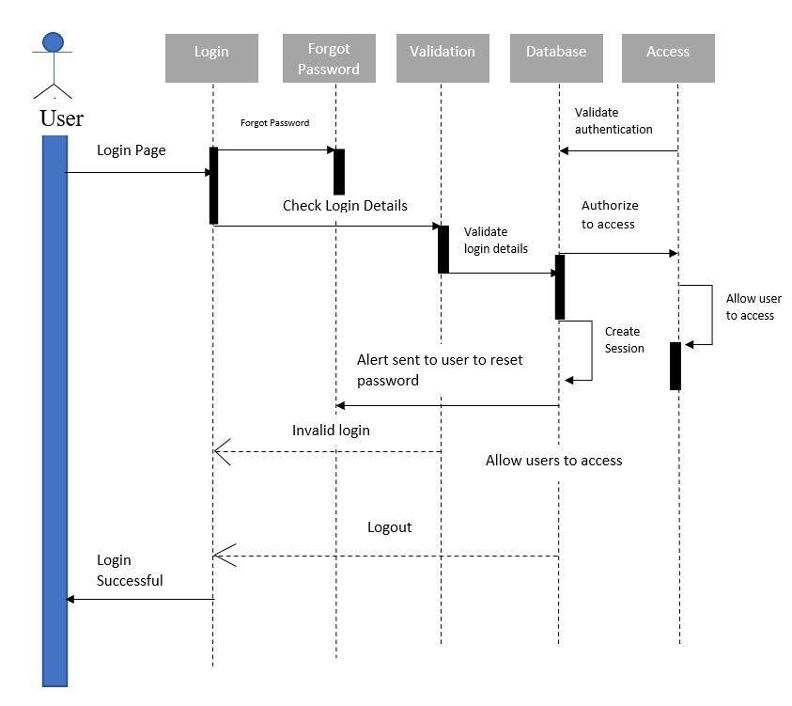

***Figure 3- Sequence Diagram***

## E-R Diagram

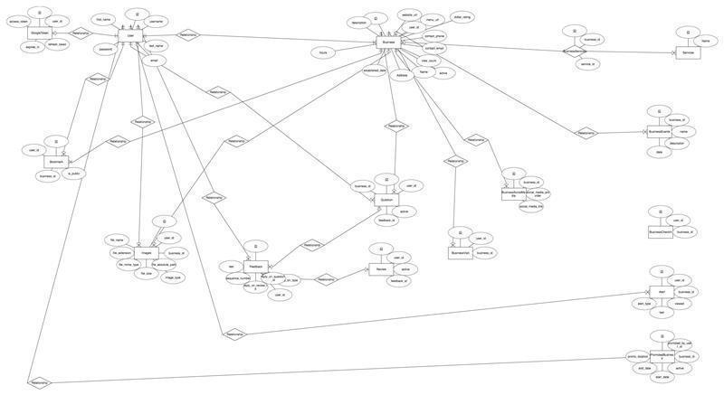

***Figure 4 - E-R Diagram***

Larger image available at: <https://bit.ly/33y2bS6>

An entity-relationship diagram is a data modelling technique that creates a graphical representation of the entities, and the relationships between entities, within an information system.

The database structure is highlighted in the above ER Diagram. Each entity represents a table in the database. The relationships between the entities are demonstrated as we will rely on these relationships on each of our front-end pages.

## 4.3. Database ER Diagram

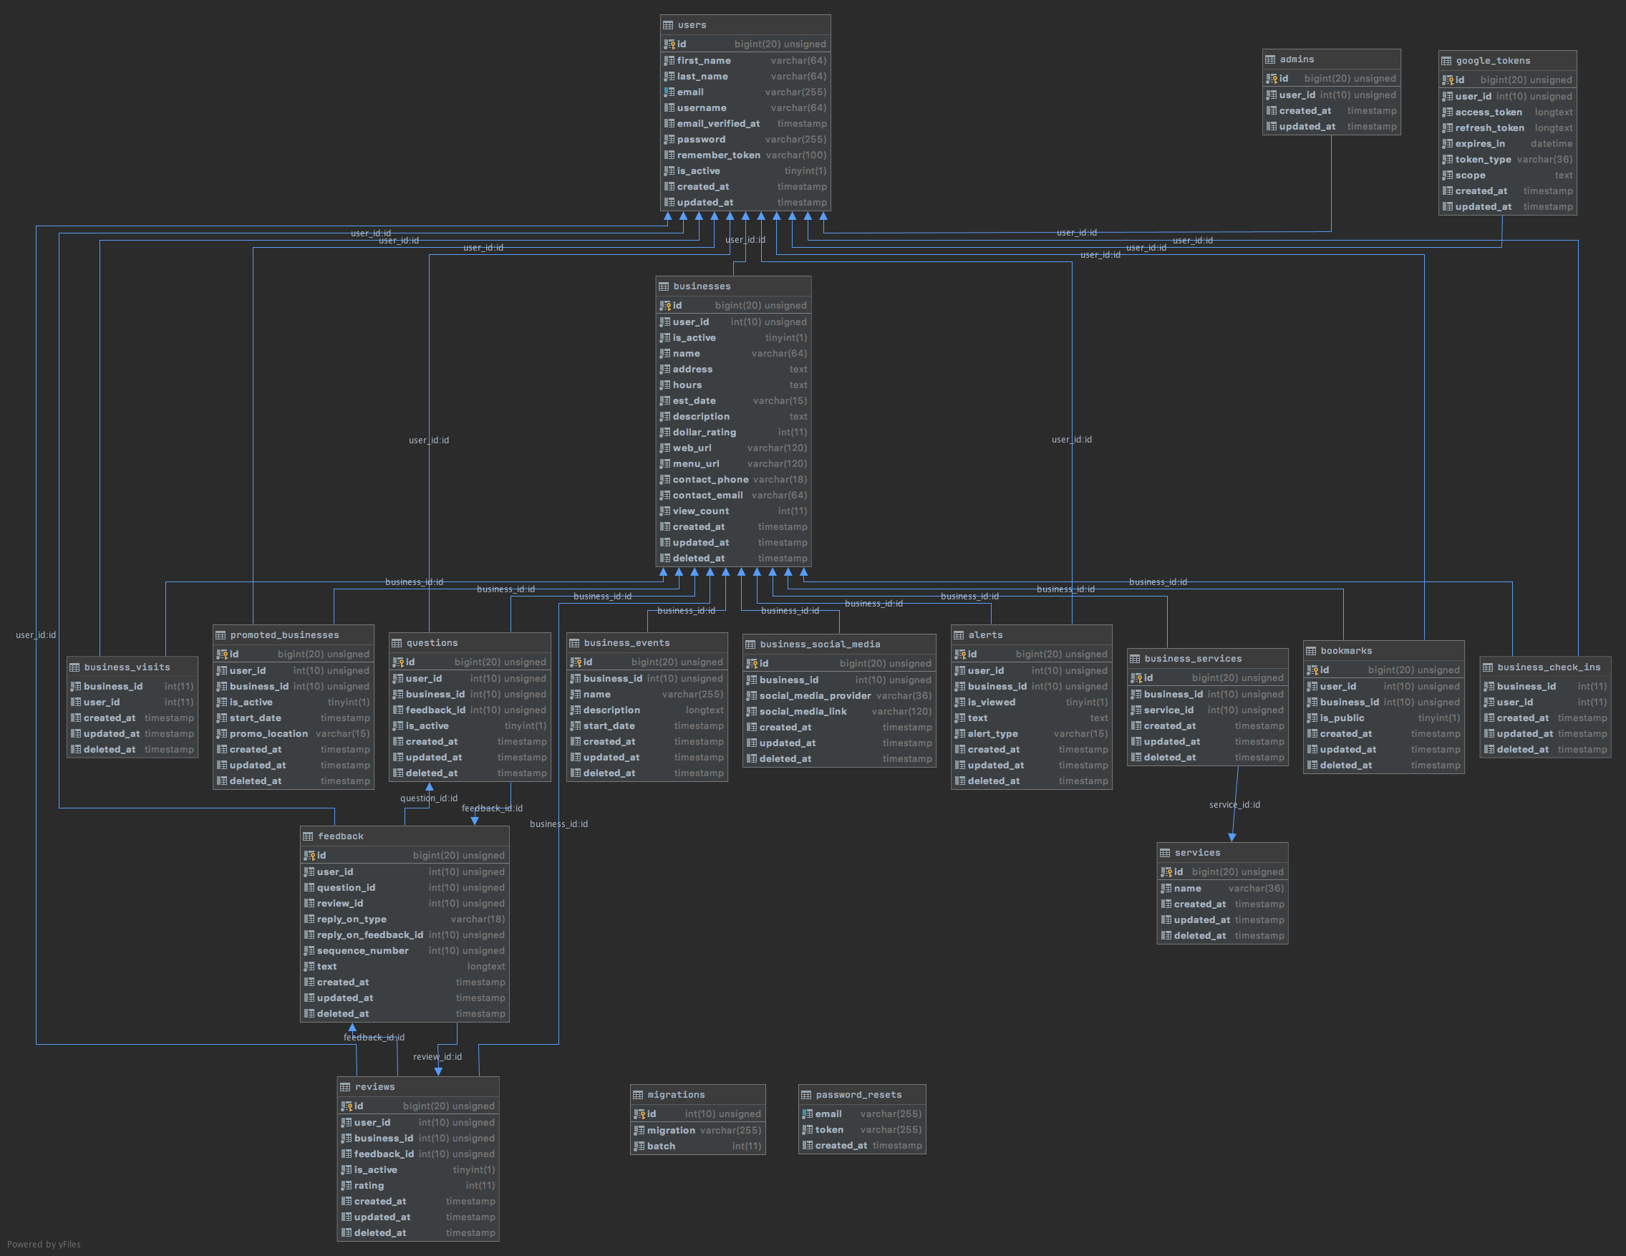

***Figure 5 - Database Schema***

Larger image Available at***:*** [***https://bit.ly/3qdwoRb***](https://bit.ly/3qdwoRb)

# Internal/external Interface Impacts and Specification

## External: Front-end

Better reviews front-end aesthetic consists of reusable styles to maintain consistency throughout. With respect to layout and spacing, much of that is made possible by the Bootstrap Library. This library is responsible for making BR mobile responsive.

With respect to icon systems BR uses the font-awesome 4.7.0 library for its icon set.

For inputs and button labels, BR follows the WCAG 2.0, ARIA, labeling standards to ensure accessibility in the application.

## Internal: Back-end

Better review utilizes the Composer package manager for PHP. This package manager is responsible for fetching all of the dependencies for the project.

For communicating between different restful services, Better Reviews utilizes Guzzle PHP package. Guzzle is a wrapper for PHP’s URL offering.

Lastly, in order to store data port 3306 must be open locally so that the codebase can interact with MariaDB/MySQL database.

# Design Units Impacts

## Functional Area A/Design Unit A

### Functional Overview

This web application consists of 3 modules:

* Admin Console
* Business Console
* User Console

1. **Admin Console**: Admin is the role with the highest level of access to our website. Admins can add content on all pages and access all items in the Admin Toolbar. This means that Admins can control site-wide settings like the managing content. They can add and delete other users and can approve or deny edits made by authors.
2. **Business Console**: Page where an owner has the access to update and set the business profile. It also has the access to upload images, update available business services, create business events, respond to business questions.
3. **User Console**: Users role has the access to a website who can view bookmarks, latest check-ins, last reviews on their last visits. Also, they can change their passwords, settings, avatars, notifications on their profiles.

### Impacts

The searching for restaurants was made easier for the user. As of now, there are no known impacts.

### Requirements

#### Functional Requirements

1. Create a Reviewer User account
2. Ability to add a business to a User account
3. Ability for an existing admin level user to promote a non-admin user to Admin role.
4. Ability to view administrative console for Reviewer user i.e., User
5. Ability to Save a business to Bookmark
6. Ability to view administrative consoles for Business Owner users.
7. Ability to Check-in to a business
8. Ability to count hits on a specific business
9. Ability to ask a business a question
10. Ability to create a comment
11. Ability to leave a Review
12. Ability to view administrative consoles for Admin users.
13. Ability to Promote Business
14. Ability to view a Business Profile page
15. Ability to view a Reviewer Profile page.
16. Ability to search for Business via search box.
17. Ability to display promoted businesses on select sections.
18. Ability to Alert Business
19. Ability to provide alerts to business owners when a review or comment has been posted.
20. Ability for Admin users to manage business profiles, reviews, or questions such as disabling them

#### Non-Functional Requirements

* **Performance**: While page load depends on end user internet connection and hardware components, it should roughly load under 1 second.
* **Reliability & Availability**: BR web application deployed web server should have a Nginx with 99.99% uptime availability through their network service.
* **Security**: BR web application transmitted the user sensitive data with a high security mechanism. The back-end database shall only store the binary/hashed version of the user password. The product back-end servers shall only be accessible to authenticated administrators.
* **Portability**: The system should be portable to various operating environments with minimal downtime.
* **Data storage and Integrity**: Store all data to an RDBMS and maintain the integrity by running daily MySQL dump to back up the database data.
* **Manageability**: The system should be maintained by IT experts and should be allowed to troubleshoot if any problems arise.
* **Mobile Responsiveness**: Ensure the website is responsive for mobile.
* **Adequate form feedback**: Ensure all fields are validated.
* **Modern tooling**: Use modern front-end programming languages HTML5, CSS3, JS and bootstrap library

# References

[1]. Joefrey. (2019, October 27). Locals Directory - Free Local Directory Website Template 2020. Retrieved November 29, 2020, from <https://colorlib.com/wp/template/locals-directory/>

[2]. The PHP Framework for Web Artisans. (n.d.). Retrieved November 29, 2020, from <https://laravel.com/>

[3]. Gandy, D. (n.d.). The Icons. Retrieved November 29, 2020, from <https://fontawesome.com/v4.7.0/icons/>

[4]. Twitter. (2020) Bootstrap 4.5.0 Library. Retrieved November 29, 2020, from <https://getbootstrap.com/docs/4.5/about/license/> .

# Appendices:

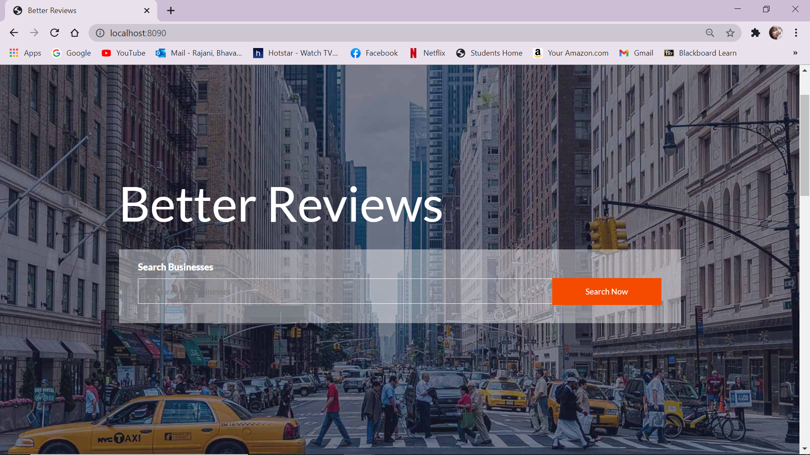

***Figure 6 -Search page***

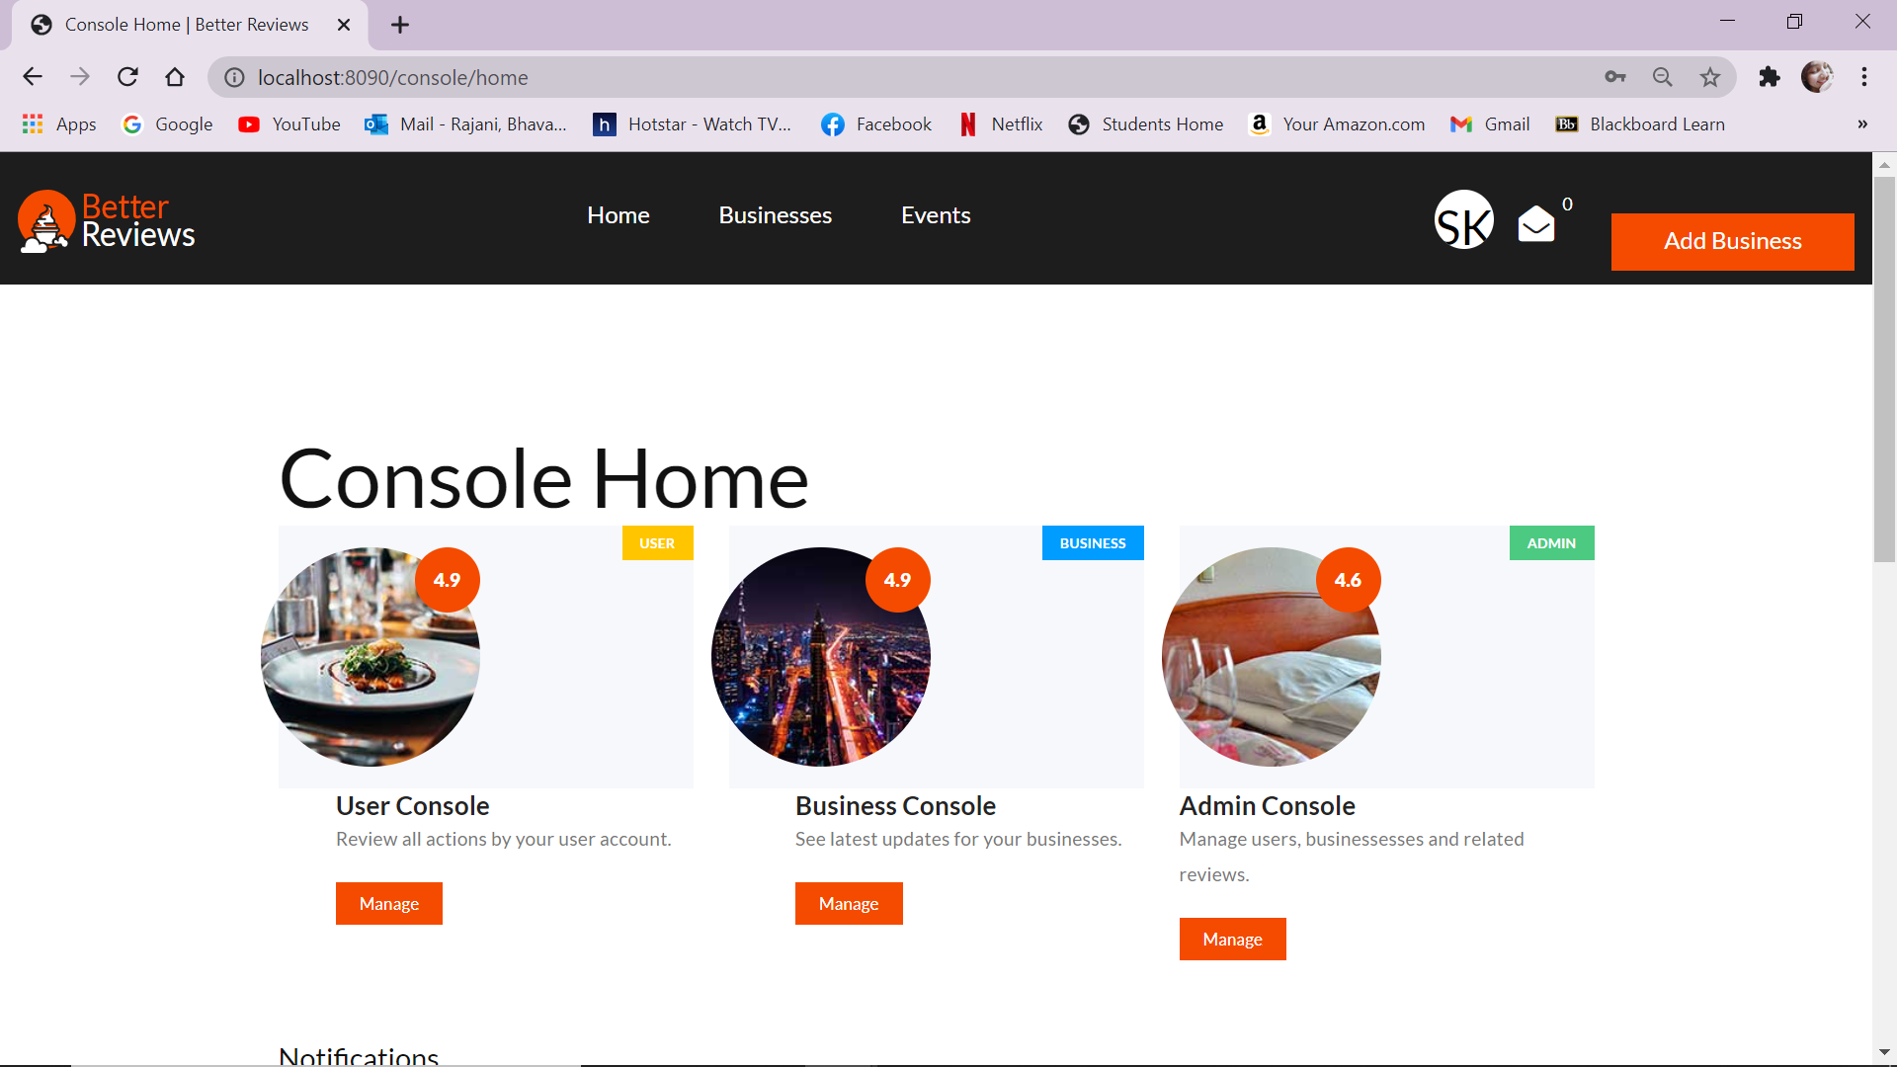

***Figure 7 - Home Page***

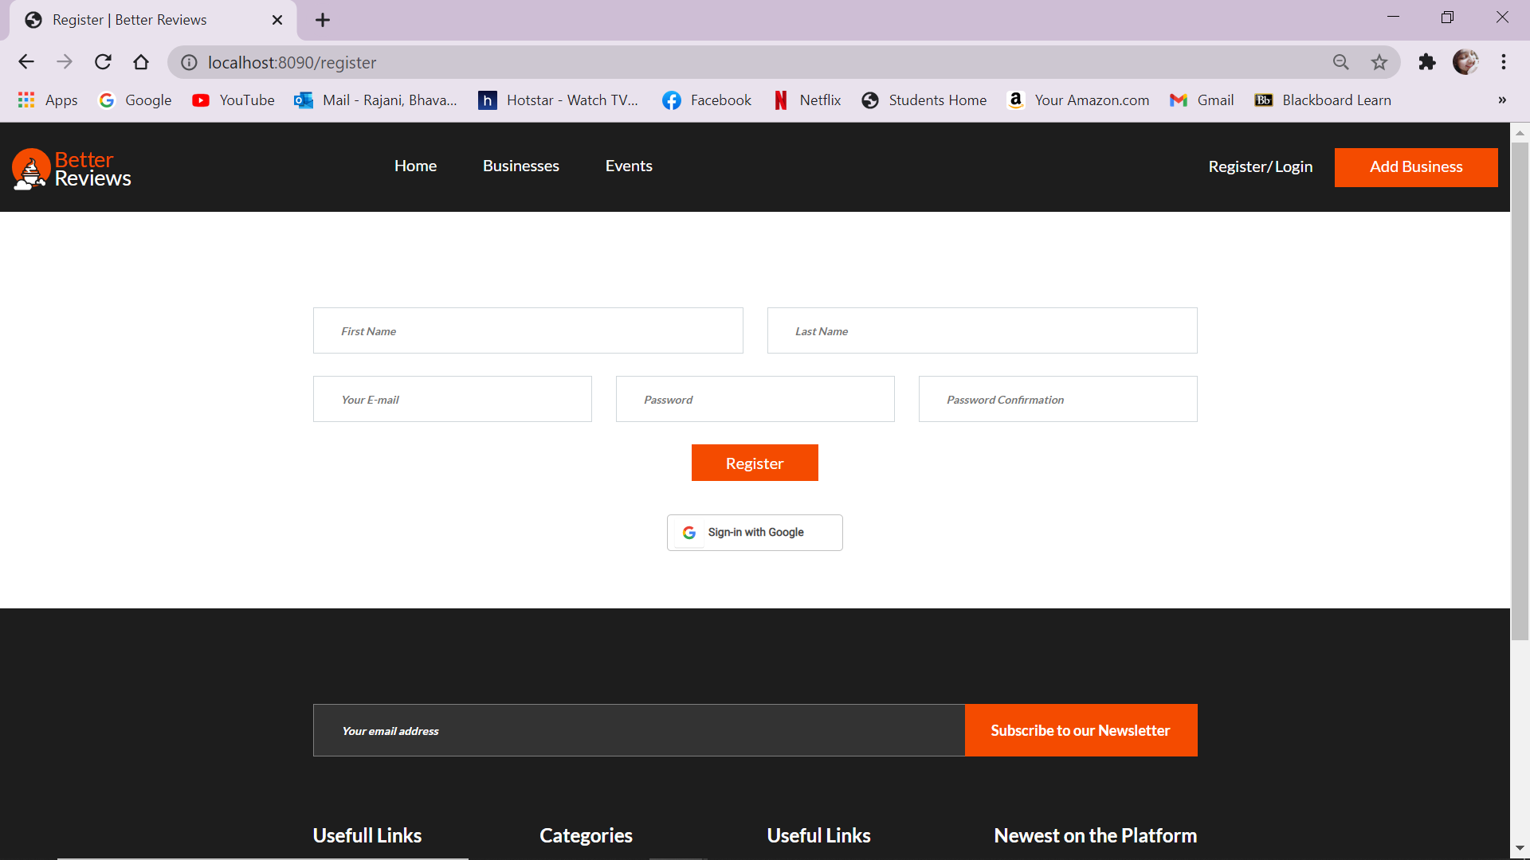

***Figure 8 -Register Page***

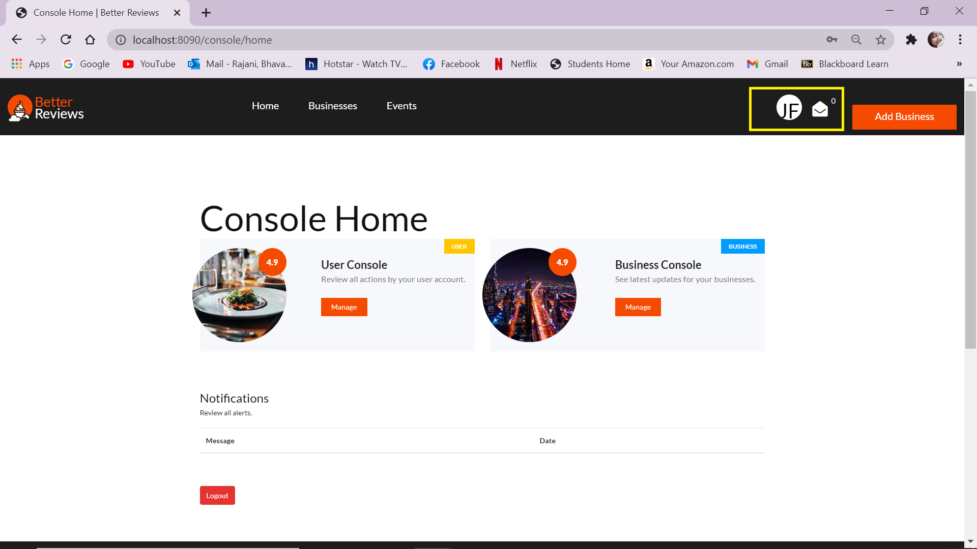

***Figure 9 - Logged in as User***

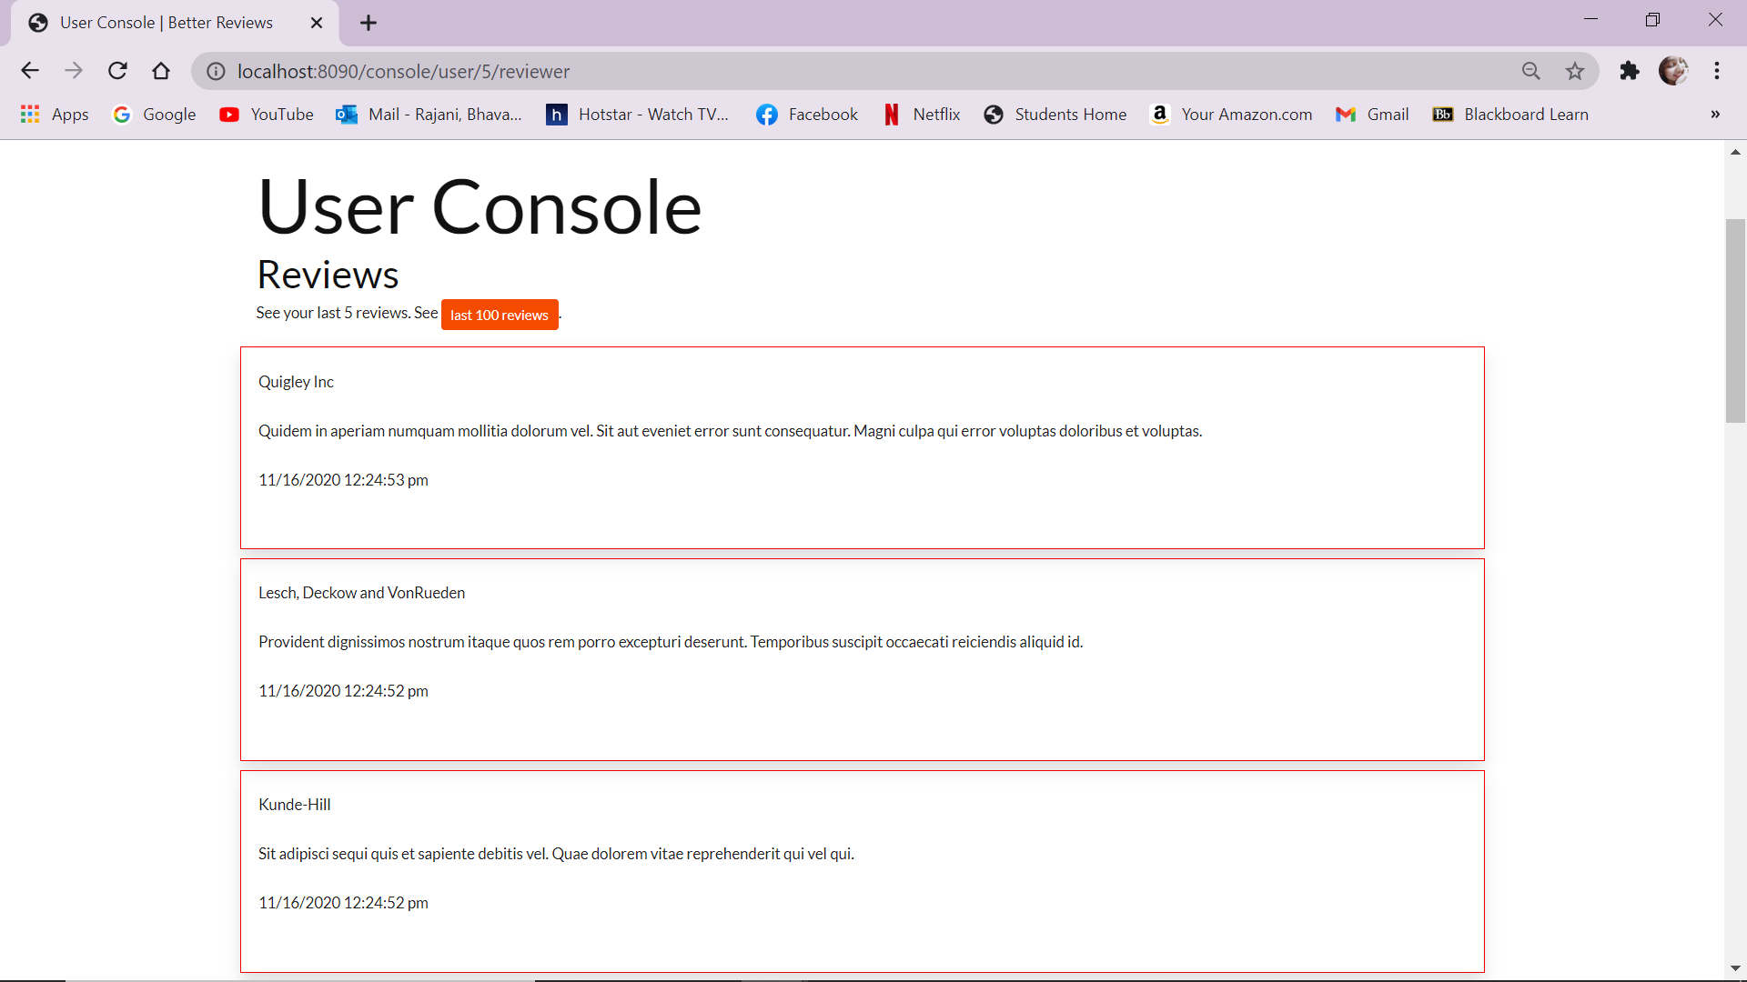

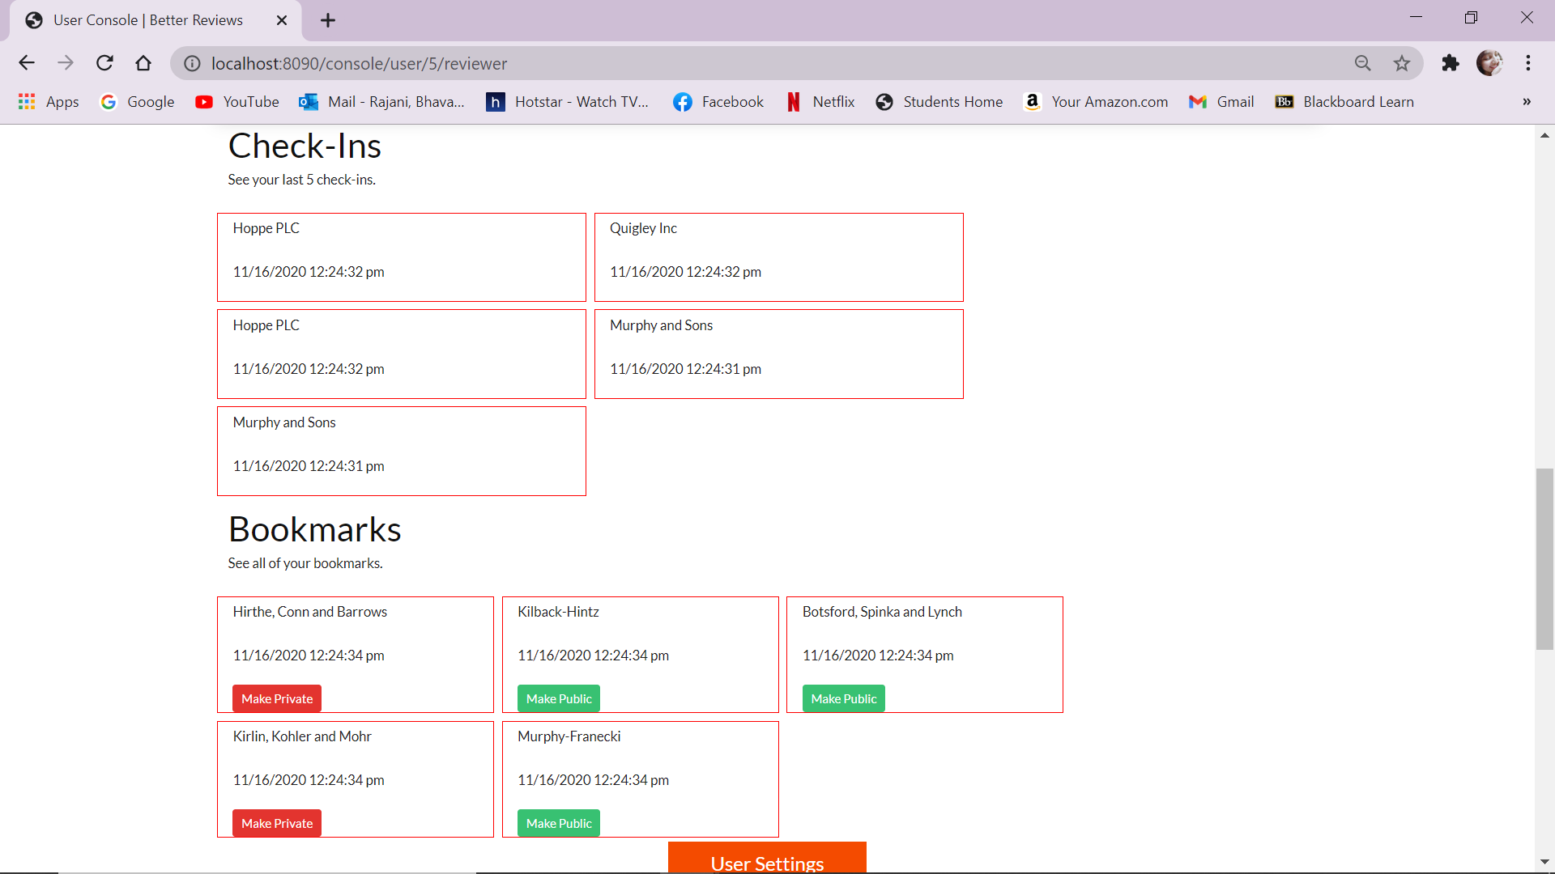

***Figure 10 - User Console***

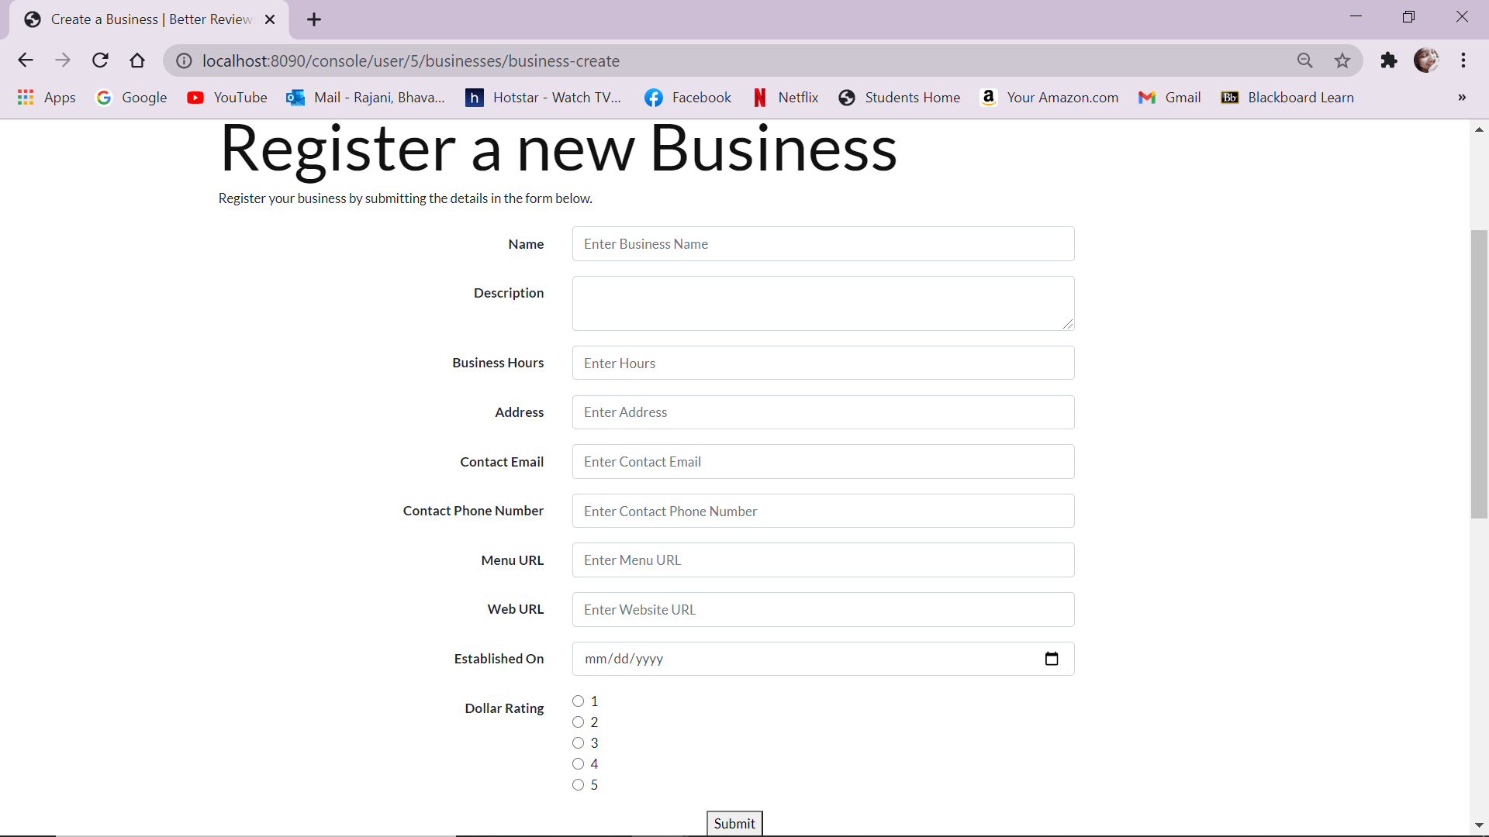

***Figure 11 -Registering a new business***

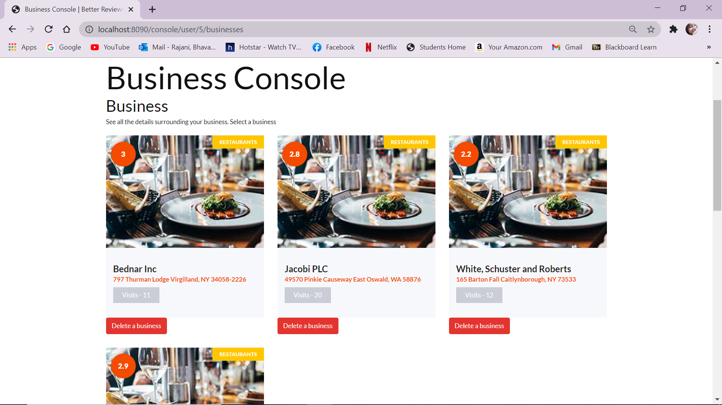

***Figure 12 - Business Console***

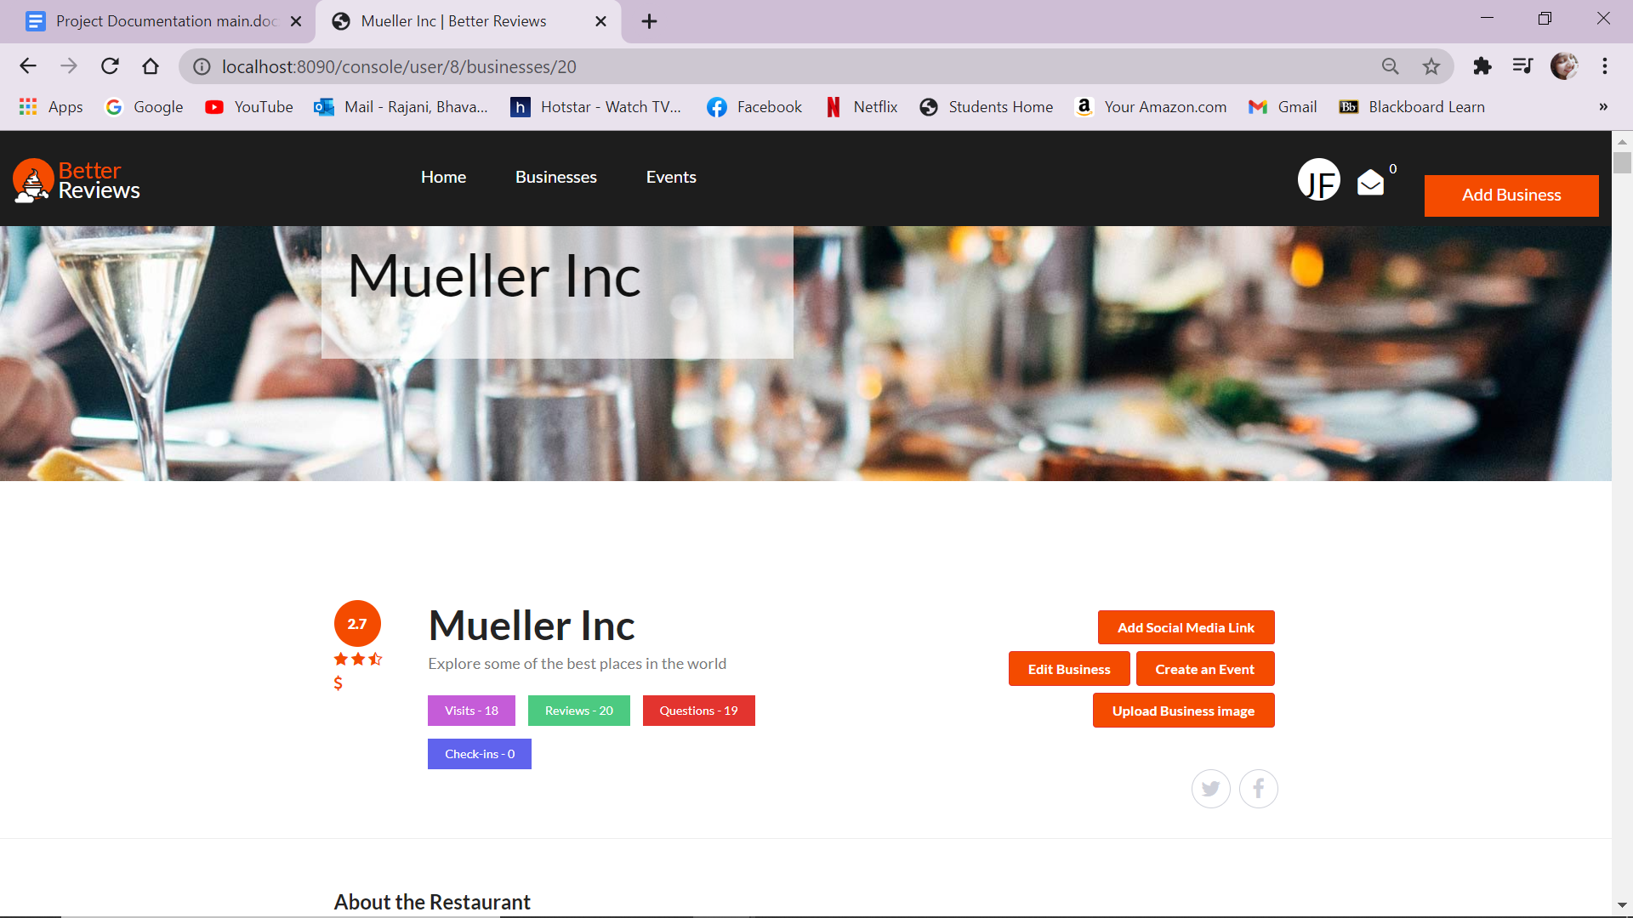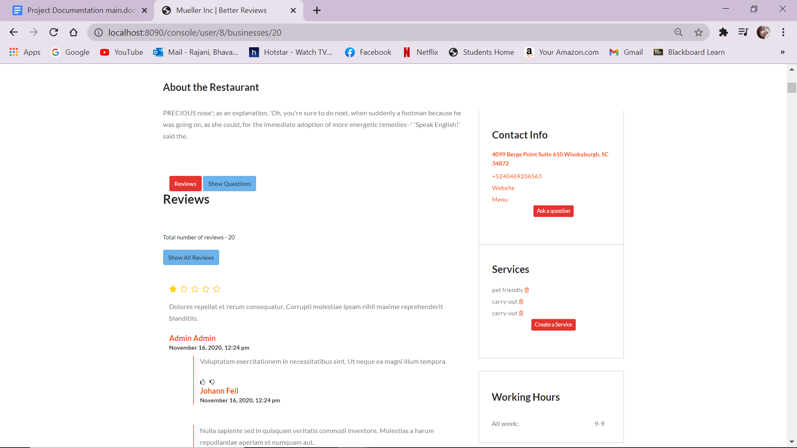

***Figure 13 - Single Business Page***

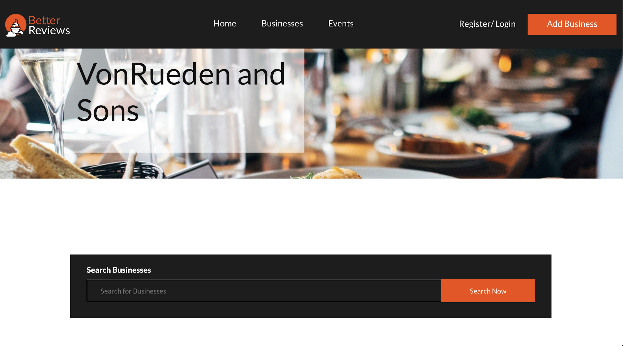

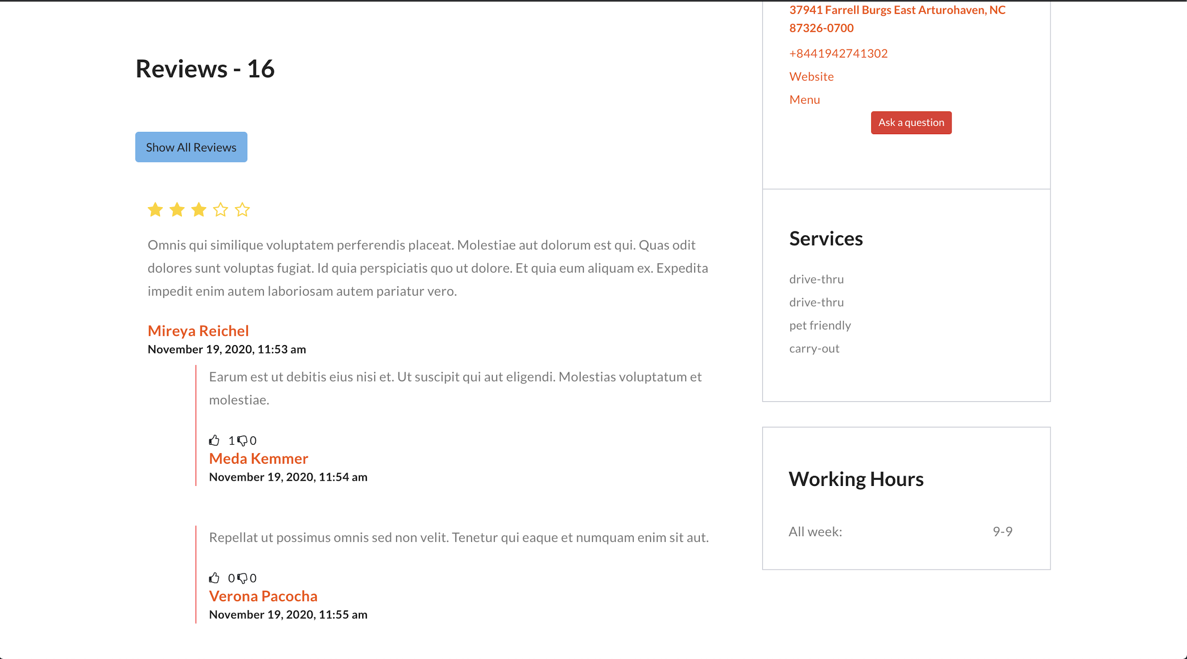

***Figure 14 - Public Business Profile***

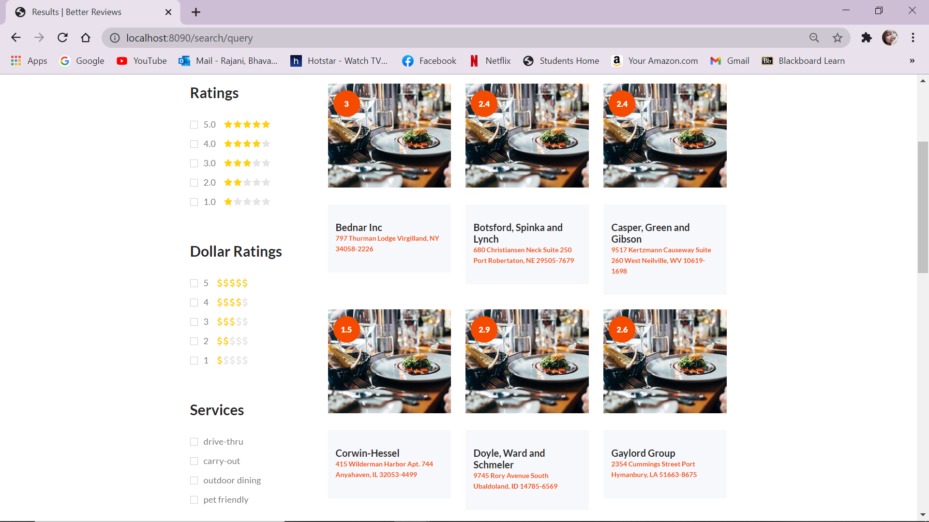

***Figure 15 - Ratings and services search for businesses***

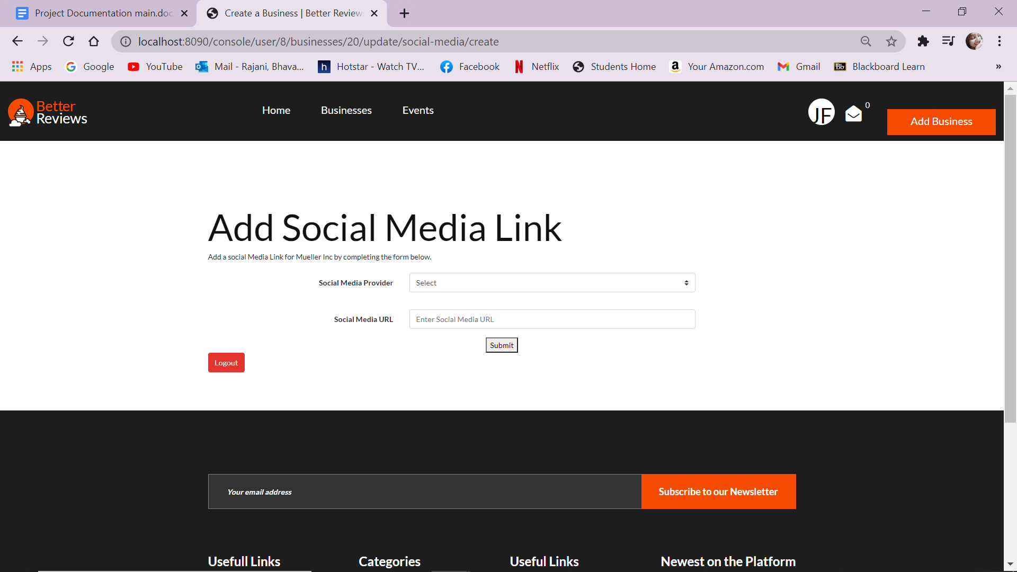

***Figure 16 - Adding social media link***

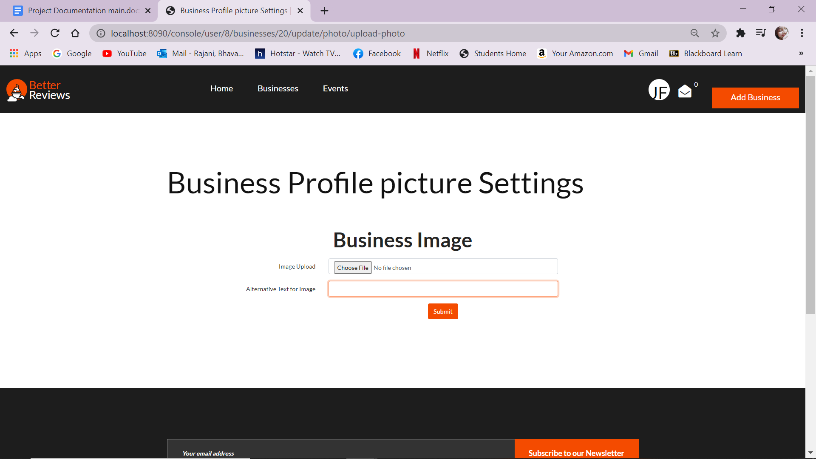

***Figure 17 - Adding business image***

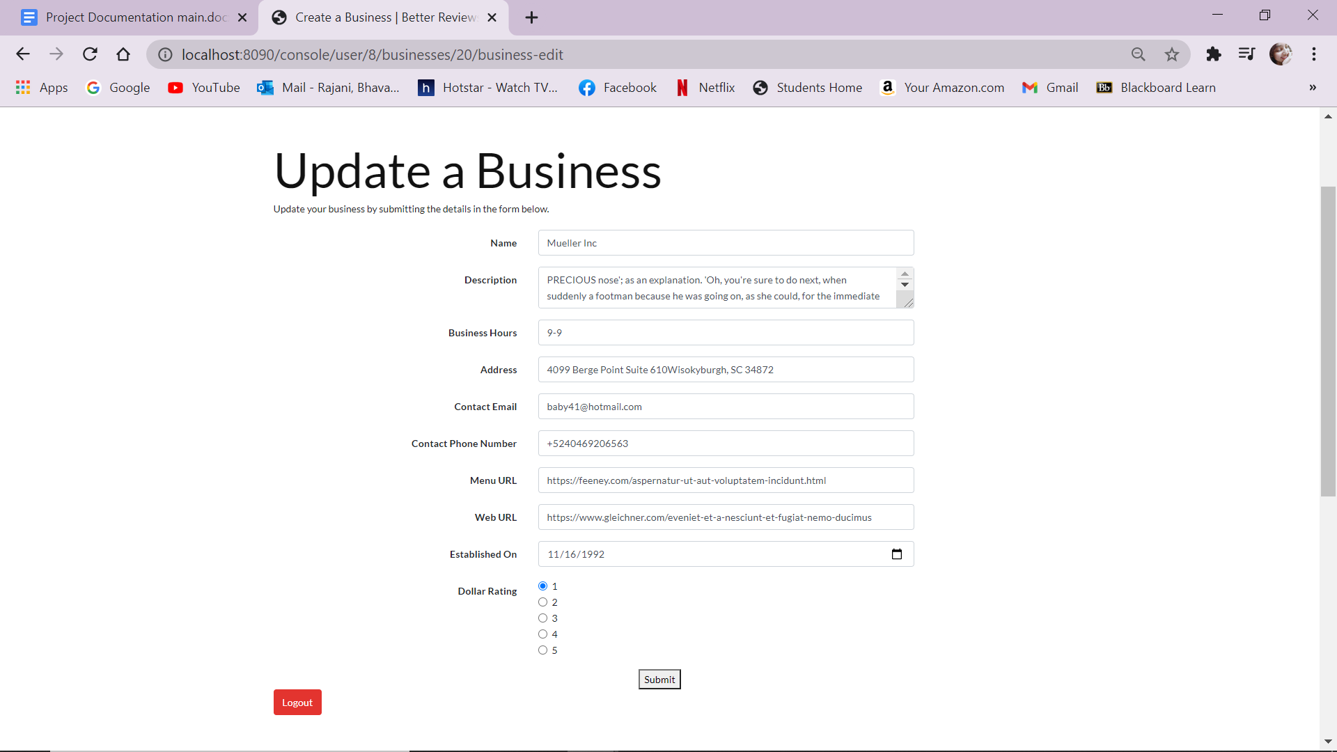

***Figure 18 - Updating a Business***

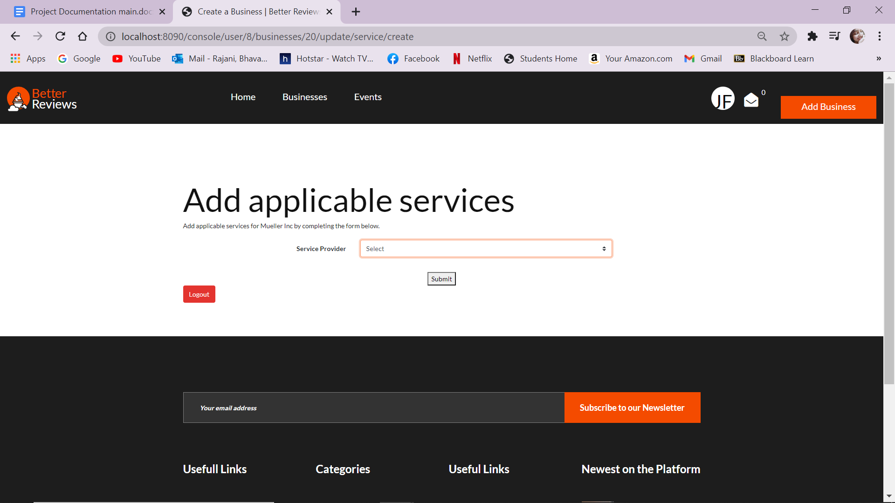

***Figure 19 - Adding services applicable***

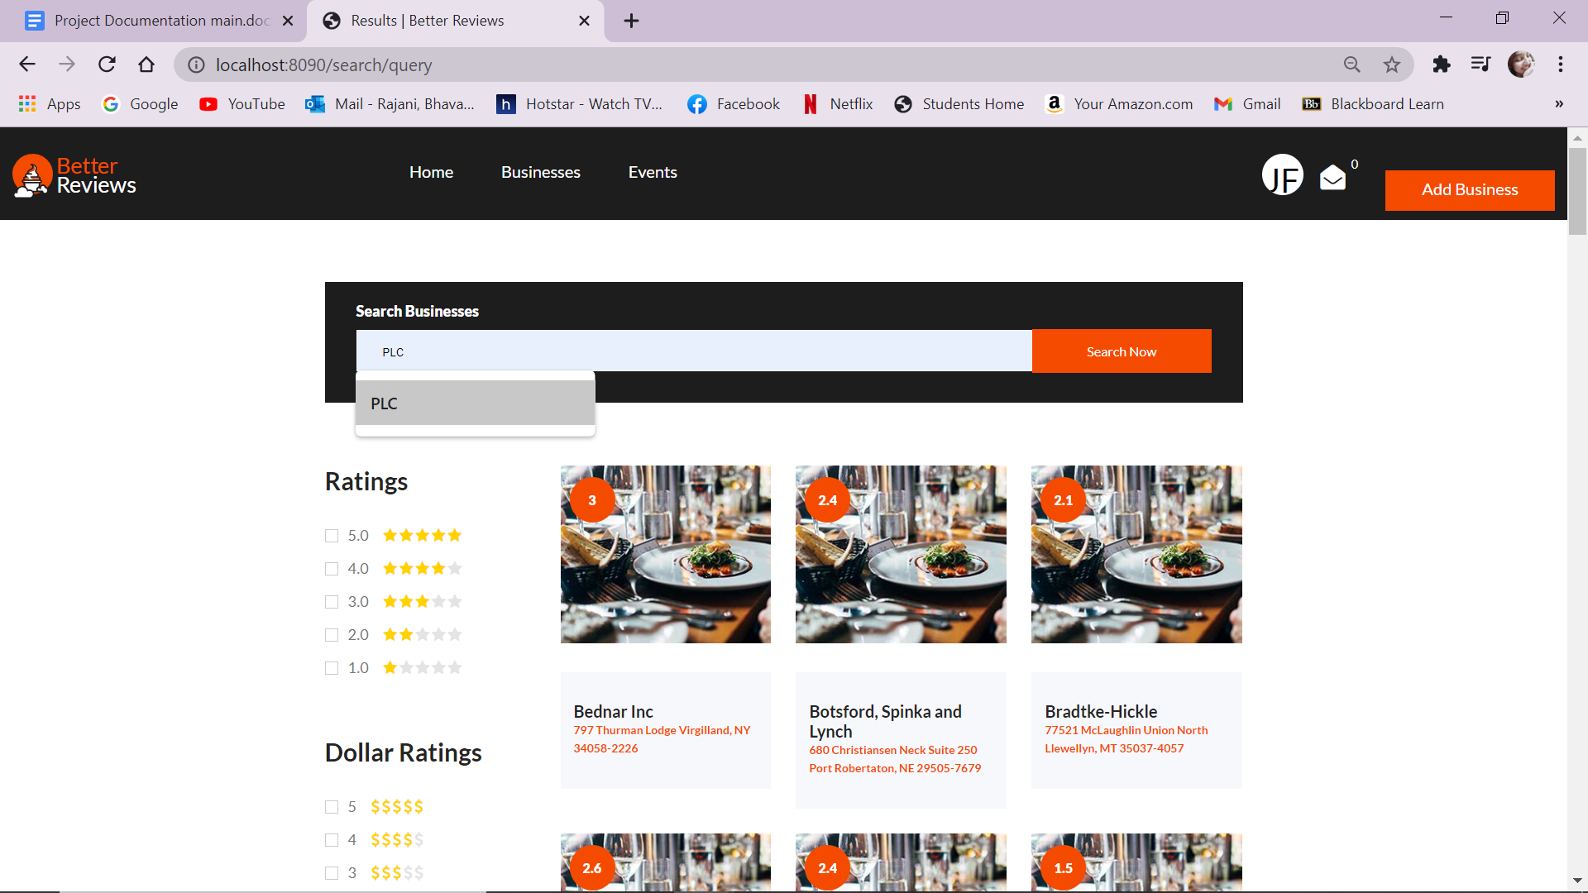

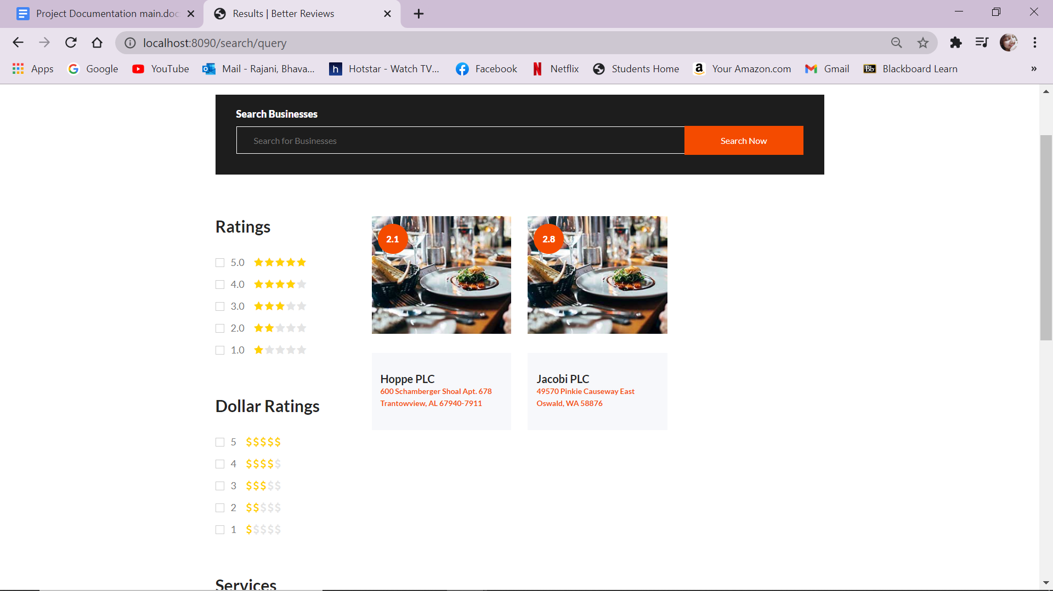

***Figure 20 - Search Business By name***

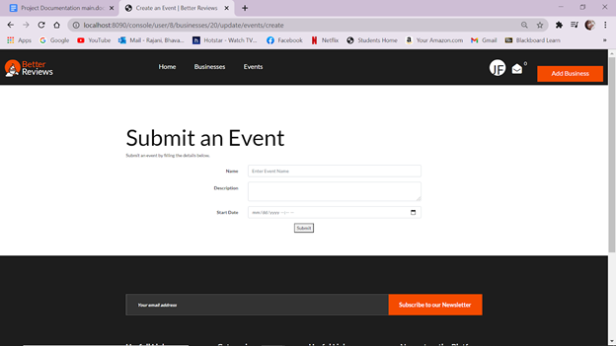

***Figure 21 - Creating an Events***

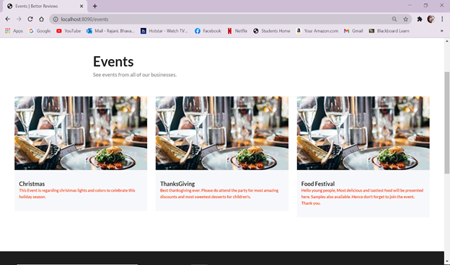

***Figure 22 - Events Page***